VIRTUAL WORK EXPERIENCE
Babcock Marine/International
https://www.s4snextgen.org/Opportunities/View/id/2247
Do you have an interest in engineering, project management, software engineering? Then this is the placement for you. The 3 day virtual work experience will cover a wide variety subject and topics that all related to what happens at Babcock day to day. The experience will cover: Mechanical Engineering, Supply Chain Project Management, Software Engineering, CV Writing and mock interviews and talks from other graduates and apprentices at the company.
Dates: 26th to 28th October 2021
Eligibility: 15+
Application Deadline: 8th October 2021
Devon Training Hub
https://www.s4snextgen.org/Opportunities/View/id/2127
Allied Health Professionals - Who they are, what do they do and what roles are available? Learn more about roles such as Speech and Language Therapists, Paramedics, Radiographers, Operating Department Practitioners and many more!
Date: 19th October 2021
Eligibility: 14 – 19 year olds
Application Deadline: 10th October 2021
Somerset NHS Foundation Trust
https://www.s4snextgen.org/Opportunities/View/id/2108
Join Somerset NHS`s Multicultural Network on the 26th October 2021 between 9:30 - 12:30 to find out more about working in the NHS and the wide range of career pathways available. Throughout the session you will have the opportunity to: Meet professionals from the Trust`s Multicultural Network, who work in the health sector across Somerset; Hear about their job roles and career journeys; Ask questions to find out whether a career in the NHS is for you.
Date: 26th October 2021
Eligibility: 14 – 19 year olds
Application Deadline: 10th October 2021

INVESTin
Experiences in Law, Business & Politics Ages 12-18. At UCL and around the UK
This term we are offering your students immersive weekend experiences in 9 careers relating to Law, Business and Politics. Learn from top criminal barristers, investment bankers, MPs, management consultants, corporate lawyers, United Nations staff and more.
Students can attend in-person at UCL or live online, with some options around the UK too. We expect to be fully-booked for the November Young Lawyer and Young Investment Banker programmes by next Friday 15th October.

UNIVERSITY TALKS

‘Should I do a General Engineering course or should I specialise?’
In this session we will focus on General Engineering degrees and why students might choose to generalise first before specialising. We will be joined by Dr Alex Askounis, Lecturer in the School of Engineering at UEA and Dr Andy Nichols, Lecturer at The University of Sheffield, who will discuss the academic content of their modules, bring to life how undergraduates are taught, and explore how the General Engineering approach supports students to specialise further into the degree or afterwards.
- October 12 @ 16:15 - 17:15 General Engineering - University Module Insights - Sheffield & UEA (KS5) Find out more »

Dr James Hodkinson from the School of Modern Languages and Cultures at the University of Warwick presents Where do you come from? Mixed Identity in Multicultural Germany.
This interactive tutorial is supported by a Headliner 20 minute recording which explores the two, sometimes three, generations of Germans with ‘migrational heritage,’ who can experience a complex sense of identity and examines the role of language, culture, and history in shaping their experiences and their sense of self. The live tutorial asks students to look at a range of short texts and images and explore the topic of ‘mixed’ or ‘hybrid identity’. Despite the direct focus on Germany, the session will engage students of any MFL subject dealing with multicultural topics.
- October 11 @ 15:35 - 16:20 Modern Languages: Linking Language, Culture & Identity - Tutorial - Warwick (KS5) Find out more »
'Why did Germans vote for Hitler?' on 20th October, we have two excellent sessions from the History Department at Goldsmiths, University of London, which address the rise of Hitler and British Foreign Policy with respect to Nazi Germany.
The interactive tutorial with Professor Alexander Watson on 20th is supported by a Headliner 20 minute recording which draws on new research to explore why Germans voted for Hitler, examining how religion, class and unemployment shaped the constituencies which supported the Nazis whilst reconstructing how propaganda, passions and a polarised ‘culture war’ brought about Hitler’s rise. Alexander then poses incisive questions for the live discussion on 20th.
- October 20 @ 12:00 - 13:00 History: Why Did Germans Vote For Hitler? - Goldsmiths (KS5) Find out more »
Maths Headliner with UEA.
The Headliner is a 20 minute recording which, in this case, features the excellent Professor Shaun Stevens, Head of the School of Mathematics at UEA, and explores the nature and application of Complex Numbers whilst posing some pertinent and challenging questions for discussion.
Students and teachers are then invited to a live tutorial with Shaun on 11th October which will further the depth of students' understanding of the topic whilst enabling them to access and experience a live online university tutorial. It is ideally suited to students who are studying complex numbers or are due to do so.
The Headliner video and the link to sign up to the live tutorial can be found using the link below:
- October 11 @ 16:45 - 17:30 Mathematics: The Nature & Applications of Complex Numbers - Tutorial - UEA (KS5) Find out more »
Dr Jenny Elliott from University of Nottingham asks the question 'What's the Point of School?
This is an excellent opportunity for groups and individual students to explore the sociological, political and economic values, among others, that drive schools and how they coincide or conflict with students' own personal values.
- October 13 @ 14:15 - 15:00 What's the Point of School? with Nottingham (KS5)
Find out more »
Brian Reed, course leader of both BA Illustration and BA Graphic Design at Solent University, who will lead a highly interactive album art design workshop designed to give students an insight into what makes a great and iconic record cover as well as an understanding of the distinction between Graphic Design and Illustration at university.
This is a great opportunity for interested students to explore how they can develop their skills and potential further at university.

- October 14 @ 16:30 - 17:30 Graphic Design/Illustration - Album Cover Design Masterclass/Workshop - Solent (KS5) Find out more »
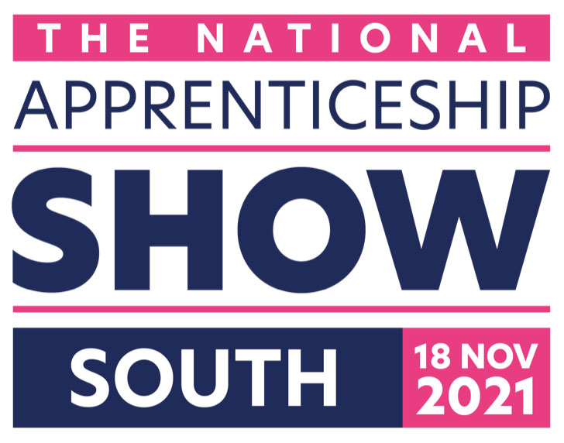https://nassouth.vfairs.com/en/

