Gifted and Talented Day at Plymstock School
On Thursday 14 June, Plymstock School hosted a Gifted and Talented event for over 50 girls from across the city. England Cricketer, Caroline Atkins worked with the girls to develop their Physical, Cognitive, Creative, Social and Personal skills. These 5 capabilities have been identified as being crucial for the development of the all-round athlete.
The girls were put through their paces with physical challenges which helped them to develop their skills within the game. They were inspired by Caroline’s testimony and how she has achieved her place on the England team. The day finished with a cricket world cup where all the girls were mixed up to represent countries from around the world.
The girls thoroughly enjoyed the day and many hope to join a local cricket club and continue to further develop their skills.

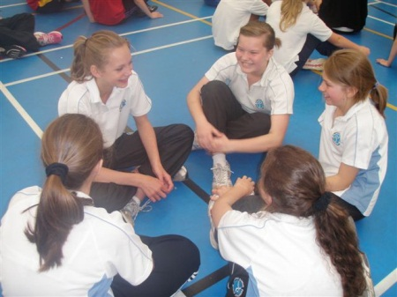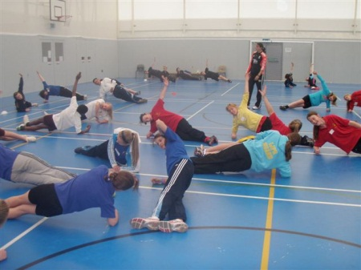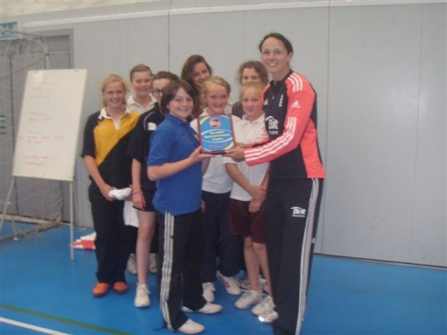

Mrs Honeywill
June 2012

